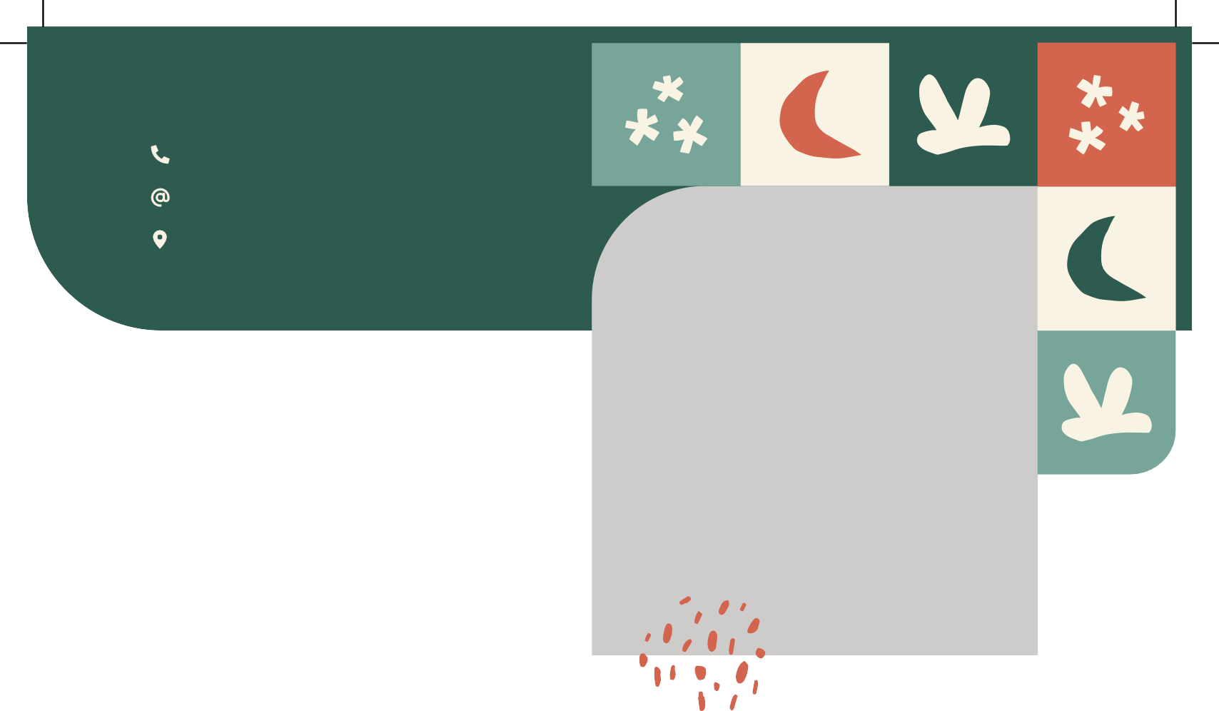

**Laura Pérez**

Asistente de Marketing

**Laura Pérez**

*Asistente de Marketing*

**Dear Mr. Samuel**

**14 de enero 2021**

**Mr. Samuel Miguel** Director Manager 39 Souttar Terrace

Mosman Park WA 6012



+00 123 456 789

[yourmail@domain.com](mailto:yourmail@domain.com) 246 Coolidge Street, CA

Eget est lorem ipsum dolor sit amet consectetur adipising. Quis auctor elit sed vulputate vitae mi sit amet mauris. In quisest ante in nibh. Sed risus pretium quam vulputate dignissim. Mi quis

hendrerit dolor magna eget est lorem ipsum.

Odio euismod lacinia at risus sed vulputate odio. Gravida cum sociis natoque penatibus et

magnis dis parturient. Enim eu turpis egestas pretium.

Sit amet justo donec enim diam vulputate ut pharetra. Vitae congue mauris rhoncus aenean vel. aliquet nec ullamcorper id sit amet risus nullam eget. Nec feugiat nisl pretium fusce. Duis

convallis convallis tellus interdum velit. Odio morbi quis Gravida cum sociis natoque penatibus.

Sincerely Yours,

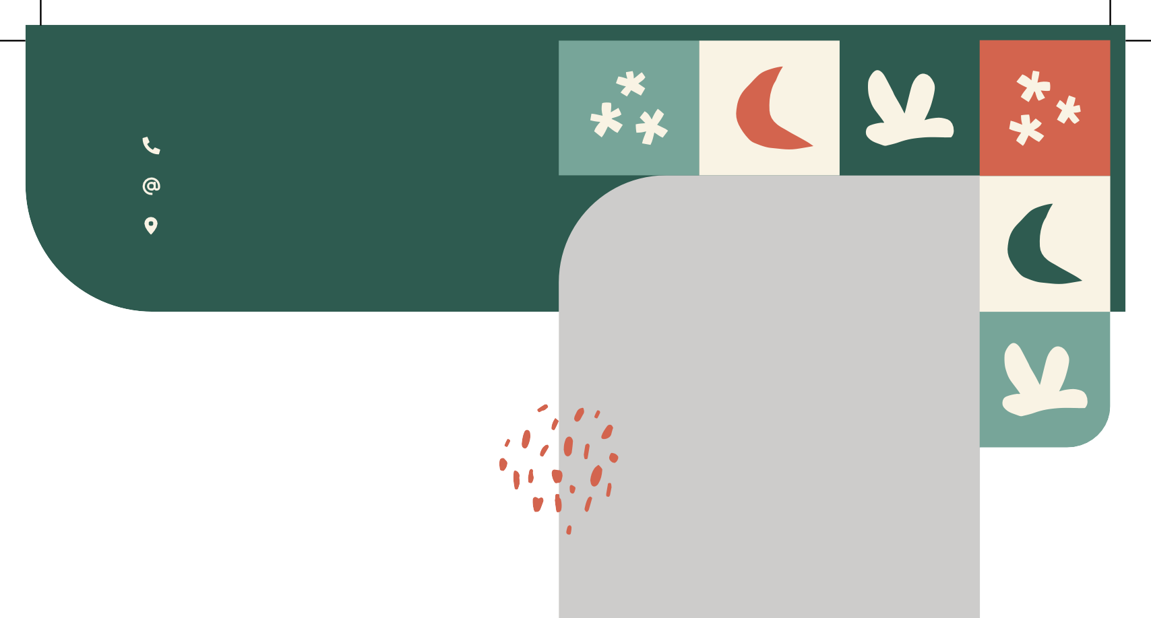



+00 123 456 789

[yourmail@domain.com](mailto:yourmail@domain.com) 246 Coolidge Street, CA

**Laura Pérez**

*Asistente de Marketing*

Eget est lorem ipsum dolor sit amet consectetur adipising. Quis auctor elit sed vulputate vitae mi

**EXPERIENCIA**

Company Name - Location Professional Job Position *(2010 - 2015)*

[*www.yourwebsite.com*](http://www.yourwebsite.com/)

**FORMACIÓN**

Business and Sociology University of Johannesburg (2006- 2010)

Company Name - Location Professional Job Position

*(2015 - 2018)*

International Business University of Applied Sciences

(2011 - 2014)

Company Name - Location Professional Job Position

*(2018 - Present)*

**HABILIDADES**

Business Development Creative Niche Development World Class Guest Relations Staff Leadership and Training Farm-to-Table Concepts

Cost Containment and Reduction

**CERTIFICADOS**

Professional Advicer Certification Certified Business Development Personal Certified Executive Advicer